Meeting Info – 4/03/2017

Attending:

Qudus

Josh

Aisha

James

Aim of meeting: Brainstorm design ideas for the extension, limited to not just the visual style but also function.

Points raised:   
Qudus – The design should fit in with other chrome extensions (uBlock Origin was used as an example)

Aisha – We need to find a credible list of untrusted sources

James – Need to find the technical details such as dimensions for icons

Josh – That we may need to use javascript instead of a c++ program using Emscripten as it there is more documentation available

Meeting outcome

Group have agreed to develop the extension in javascript/html/css instead of c++

Josh will investigate how the functionality of the program can be implemented

Aisha and Qudus are going to investigate a source that has discredited websites

James will investigate modern interfaces we can use to influence our logo.

Meeting Info – 14/03/2017

Attending:

Qudus

Josh

Aisha

James

Aim of meeting:

Discuss previous meetings research

Points raised:

James produced a sketch of a possible logo idea. Group input came that the icon did translate all the information needed to the user but could be more visually appealing and will be used as a placeholder in development.

Qudus and Aisha produced a list of sites from various different vendors but after group appraisal decided that we needed to find a trusted single author as it would be easier to add into the implementation.

Josh discussed his research into the application development and had looked through the chrome API documentation available and had found a way to detect the user’s current URL and suggested that the data could be stored in a JSON file so it could be updated independently of the core extension.

Meeting outcome

James will continue to develop the icon to create the final image

Qudus and Aisha will attempt find a single source possibly that has a data file available preferably in JSON format

Josh will begin creating the extension to be built upon between meetings.

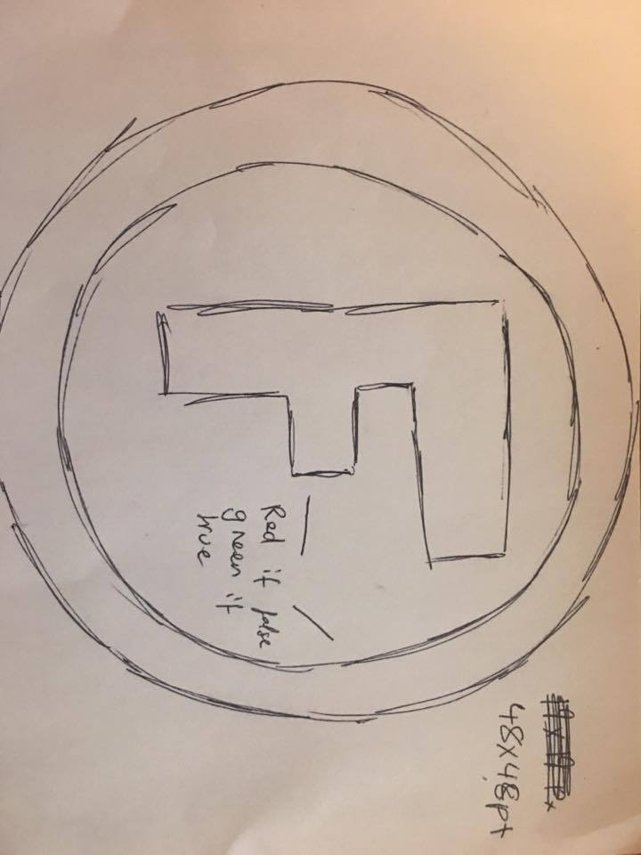

Media Produced:

Meeting Info – 23/03/2017

Attending:

Qudus

Josh

Aisha

James

Aim of meeting:

Decide on a final logo and decide on a list of sites to be added into the implementation

Points raised:

James produced a new digital logo design that the group agreed was suitable and fitted with the existing chrome design and existing extension logo’s.

Qudus and Aisha produced a source that was under GPL-2.0 that contained a json source file that will be used as a basis of checking site validity.

Josh produced the extensions manifest file and start of the background page and showed the implementation running in a barebones state (placeholder image and extension info).

We created a hand drawn design of the extensions popup page when clicked.

Meeting outcome:

James will implement the popup page in HTML and CSS

Josh will continue implementing the program using the source file found by Qudus and Aisha

Josh and James will implement a form of network storage for them access files needed during development

Media Produced:

 

<https://github.com/aligajani/fake-news-detector> (has the JSON that will be used)

Meeting Info – 04/04/2017

Attending:

Qudus

Josh

Aisha

James

Aim of meeting: Look at current progress and begin planning demo

Points raised:   
James finished the popup page and Josh finished the implementation testing showed that the application worked and a script was started for the demo.

Meeting outcome

Group members will individually improve their sections of the scripts and bring the work to the next and final meeting before the demo

Media Produced

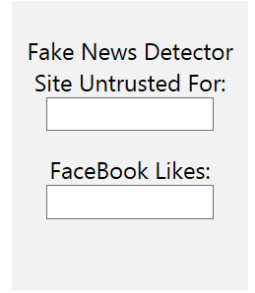

Meeting Info – 20/04/2017

Attending:

Qudus

Josh

Aisha

James

Aim of meeting: Practice demo and add finalize report

Points raised:   
Demo was run through and all group members happy with progress. Belbin tests completed by each member to be added and referenced in the report

Meeting outcome

Group members will continue preparing for the demo .